Python Programming Lab Task Sets
ROLL No- 2503B09909
Name : Nancy Kumari

Set 1
- Q1. Write a Python function to calculate the factorial of a number. Use a coding assistant and document how you refine your prompt to ensure the function handles negative input and zeros.
(Each question carries 5 marks)
PROMPT : Write a Python factorial function that handles also if user input is negative numbers and zero
CODE:
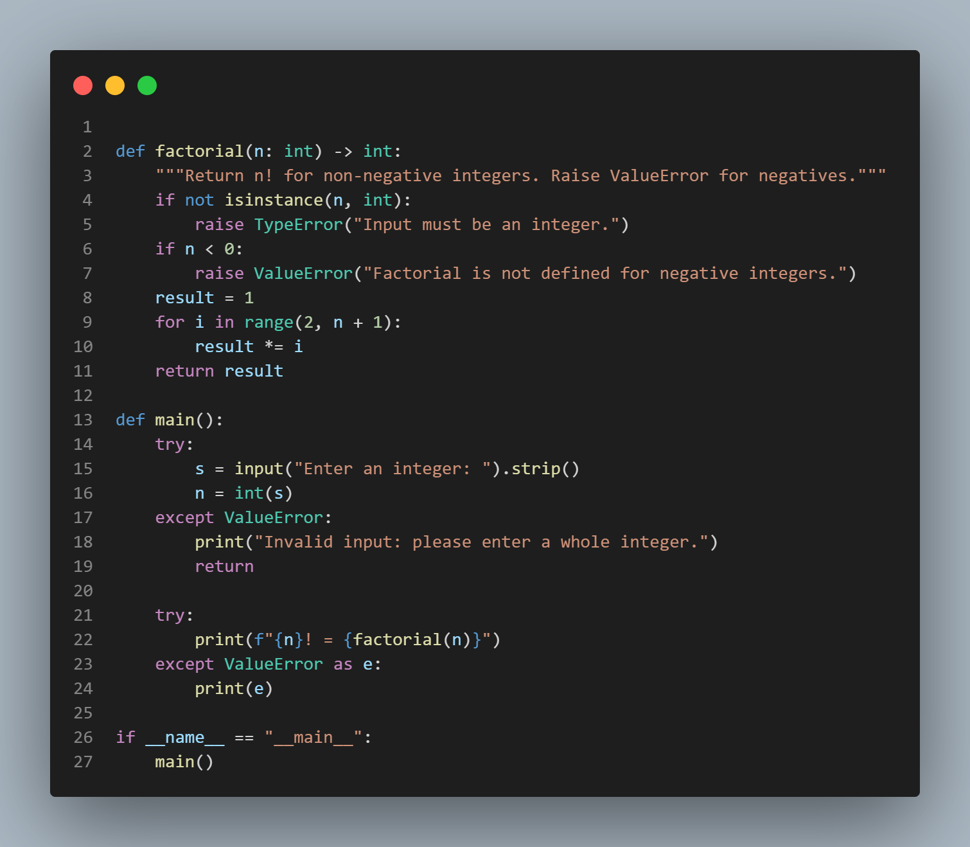
OUTPUT :
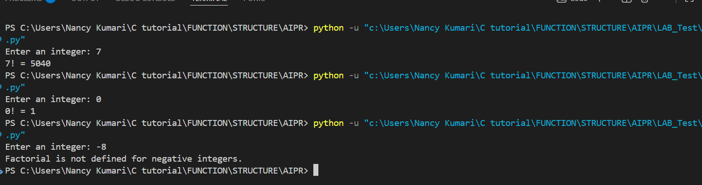
- Q2. Given a list of student marks, compute the mean and list all students above the mean. Demonstrate zero-shot, one-shot, and few-shot prompts to guide an AI tool to solve this. Summarize the differences in approach.
(Each question carries 5 marks)
zero-shot
PROMPT : Write a python code for a list of student marks, compute the mean and list all students whose marks are above the mean:
Marks: { 'A': 85, 'B': 67, 'C': 92, 'D': 74, 'E': 88 }.".
CODE:
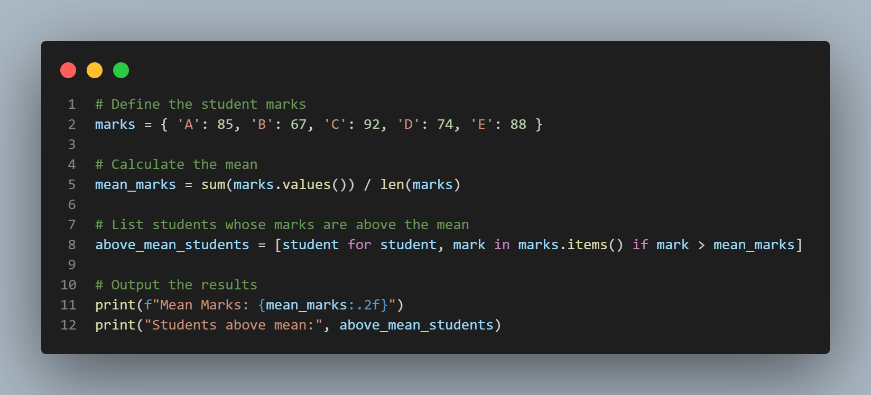
OUTPUT:
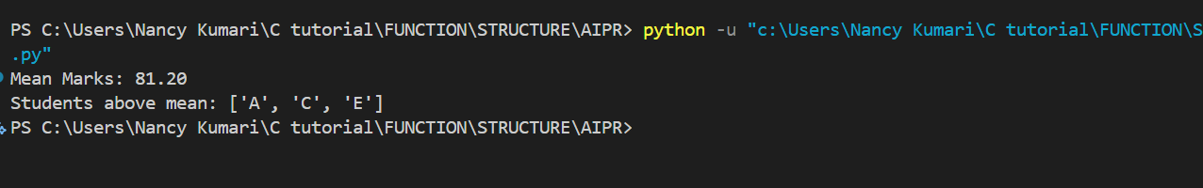
ONE-SHOT:
PROMPT : Write a python code for a list of student marks, compute the mean and list all students whose marks are above the mean:
Example:
Input: { 'A': 50, 'B': 60, 'C': 90 }
Output: Mean = 66.67, Above Mean → ['C']
Now solve for this input:
{ 'A': 85, 'B': 67, 'C': 92, 'D': 74, 'E': 88 }.
CODE :
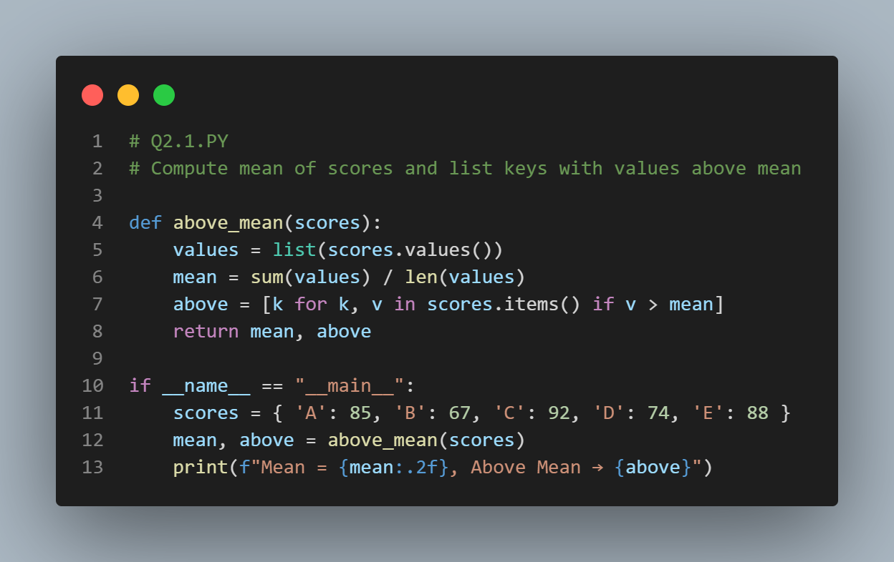
OUTPUT :
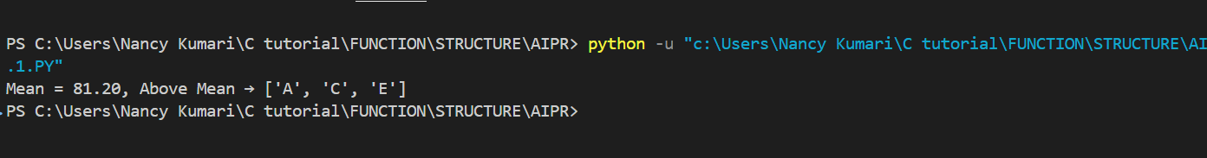
FEW SHOT PROMPT : Write a python code for a list of student marks, compute the mean and list all students whose marks are above the mean:
Example 1:
Input: { 'A': 50, 'B': 60, 'C': 90 }
Output: Mean = 66.67, Above Mean → ['C']
Example 2:
Input: { 'Nancy': 40, 'Raj': 55, 'Nandini': 80 }
Output: Mean = 58.33, Above Mean → ['Spike']
Now solve for:
{ 'A': 85, 'B': 67, 'C': 92, 'D': 74, 'E': 88 }
CODE :
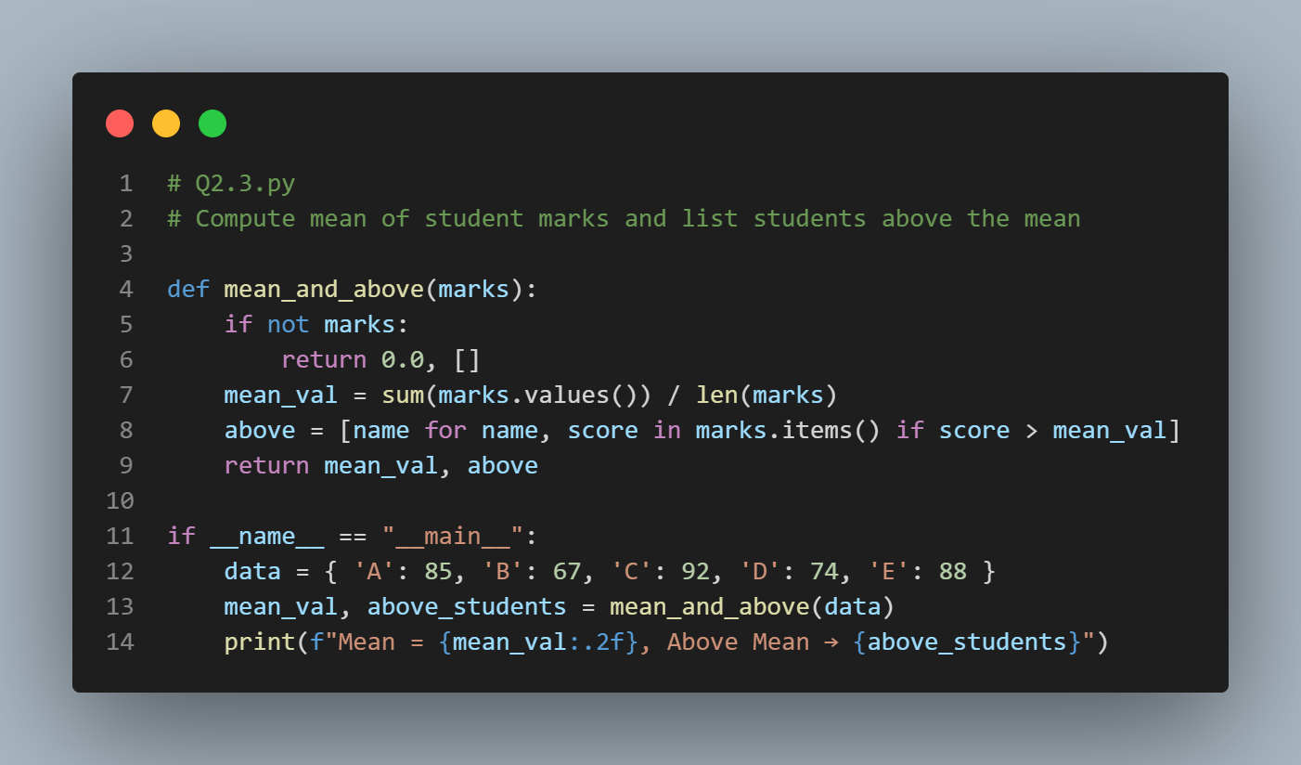
OUTPUT :
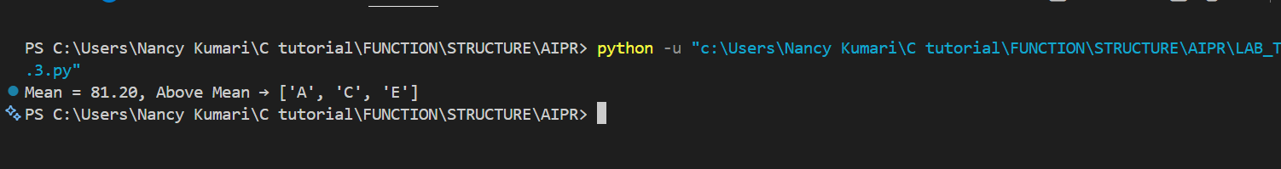
Zero-Shot
- No example is provided.
- The AI must understand the task only from the instruction..
- Useful when the task is simple and doesn’t need formatting guidance.
One-Shot
- One example is provided before the actual task.
- The AI understands the expected pattern and format better
- Useful when you want a specific answer style with minimal guidance.
Few-Shot
- Multiple examples are given.
- AI clearly learns the rule, format, and expected response style.
- Useful for complex tasks requiring strict formatting or reasoning.

